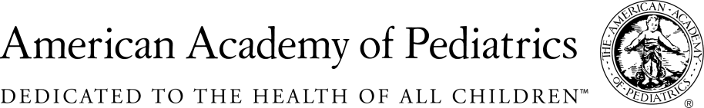
NYSAAP, District II, Chapters 1, 2 & 3
MEMORANDUM IN SUPPORT
A. 4151A /S. 04055B
June 1, 2017
The NYS American Academy of Pediatrics, representing more than 4,000 pediatricians across New York State, supports A. 4151A /S. 04055B, which would ban the sale of crib bumper pads in New York and restrict the use of such pads in childcare facilities or places of public accommodation.
The American Academy of Pediatrics has been a leader in educating parents and public officials about the dangers of crib bumper pads. The AAP strongly recommends that infants sleep on their backs, alone in a crib on a firm mattress with a tight-fitting sheet, without any soft objects or loose bedding. We have been waging our “Back to Sleep” campaign for several years. We have worked with the federal government, state and local governments to get the word out to all parents and those who care for infants. But old habits are hard to change. And the use of crib bumpers, although reduced, has not been eliminated. Passage of this bill will eliminate at least one hazard from the cribs of New York’s babies.
While crib bumper pads are purchased under an assumption that they keep infants safe, they are in fact dangerous. The Journal of Pediatrics recently reported that in the last six years 23 babies died from suffocation associated with the use of crib bumper pads. Every one of these 23 infant deaths was avoidable. And sadly, many more babies sustained serious injuries from choking on bumper pad ties or nearly suffocating.
The evidence is clear, crib bumper pads are dangerous. Until New York stops the sale of bumpers and prohibits their use in infant and child care settings, infants and children will remain in danger in a place, their cribs, where they should be safe.
Although this bill eliminates the sale of crib bumper pads, it does not completely eliminate mesh bumpers, nor single rail covers. But, it is a start. It is our hope that this can be a first step toward the complete elimination of all materials not required for Babies’ Safe Sleep.
Join us in supporting a first effort to create safe sleep environments for all infants and babies. Pass this bill, this year and help protect the infants and babies of New York.
For Additional Information Contact:
Elie Ward, MSW
Director of Policy & Advocacy
NYS American Academy of Pediatrics
eward@aap.net

