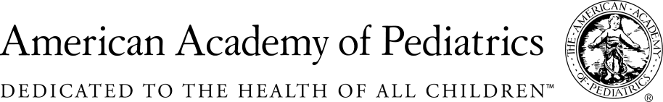
NYSAAP, District II, Chapters 1, 2 & 3
MEMORANDUM IN SUPPORT
A.00587C/S.2816B
May 17, 2018

The New York State American Academy of Pediatrics, representing more than 4,000 pediatricians across the state fully supports adding CMV testing to the newborn testing protocols within the requirements of this legislation.
Over the last several years medical advances have created options for improved quality of life for babies identified with CMV. In addition, with recent medical advances, it has been proven that the sooner CMV is diagnosed and treatment initiated, the potential chances of a more positive outcome are improved. The clear requirement that a newborn must fail anin-hospital hearing test and that the polymerase chain reaction test be used for diagnosis, follows current research in terms of the most effective testing for CMV. This clear protocol will address former issues of a significant number of both false positive and false negative results.
The added component of educating parents about CMV and teaching them about the simple act of washing one’s hands will go along way toward prevention of this disease.
We are pleased to support this legislation and look forward to an enhanced public health approach and more timely and accurate clinical diagnosis of CMV. This legislation will get us closer to our dual goals: to reduce the number of cases of newborns infected with CMV, and to diagnose and initiate treatment as early as possible for those infants infected with CMV, so they can go on to live the most productive and positive lives possible.
We urge you to pass this legislation this session and help us help the newborns and families across the state facing a CMV diagnosis.

Contact:
Elie Ward, MSW
Director of Policy & Advocacy
NYS American Academy of Pediatrics
eswabc@gmail.com

