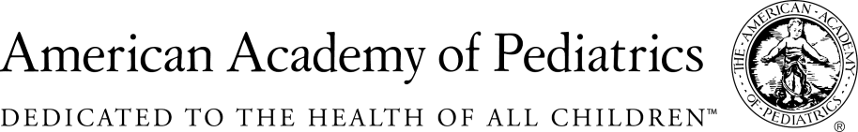
NYSAAP, District II, Chapters 1, 2 & 3

January 12, 2018

Memo of Support
A.07218a/S.5585a

NYS AAP, representing more than 5,000 pediatricians across New York State, strongly supports this legislation which requires anyone who choses an indoor tanning option to be over the age of 18.
We see firsthand how exposure to UV radiation, especially through intentional tanning, negatively impacts the health of children both now and as they age into adulthood.

Even infrequent tanning using tanning beds can lead to an increased risk of skin damage and cancer, especially if the initiation of tanning bed use occurs earlier in life. A large cohort study conducted in 2011 indicated a significantly higher increased risk of basal cell carcinoma for those who used tanning beds during high school and college as compared with use between the ages of 25 and 35, andthatindividuals who participated in only four tanning sessions per year were still at an increased risk of melanoma by 11% and basal cell and squamous cell carcinoma by 15%.

Given their developmental vulnerability, many adolescents are not able to make completely informed decisions regarding the use of these devices. A 2011 nationwide survey indicated that nearly 90% of adolescent respondents used tanning beds despite knowing that they increase the risk of skin cancer, and adolescent respondents were twice as likely to be unaware of any warning labels on tanning beds compared with adult users. Currently, state and local laws do not adequately protect children from the harms of indoor tanning and must be supplemented with a statewide prohibition on their use under age18.

Contact:
Elie Ward, MSW,
Director of Policy & Advocacy, NYSAAP
eward@aap.net.

