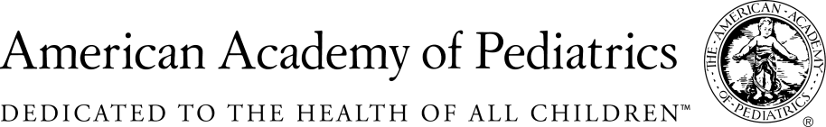
NYSAAP, District II, Chapters 1, 2 & 3

MEMORANDUM IN SUPPORT
A.521A

May 31, 2018
The New York State American Academy of Pediatrics, representing more than 5,000 pediatricians across the state supports A.521A which requires a listing of ingredients and percentages of components in menstrual products such as tampons, pads, menstrual underwear and cups on the label or in a package insert, and requires a label for single use dispensers.
Our interest in supporting this measure is on behalf of our teen patients and also on behalf of the girls and young women who will become the mothers of our future patients. The good health of all girls and women is of the utmost importance. Menstrual products such as tampons, pads, menstrual cups and period underwear come into direct contact with some of the most sensitive and absorbent tissues on a young girl’s and a woman’s body. The Food and Drug Administration has received hundreds of reports of adverse reactions to pads and tampons that have required medical evaluation and care. But currently there is no legal requirement for manufacturers to disclose the ingredients used in tampons and pads. We believe that for the safety of girls and women, manufacturers should be required to disclose the ingredients that make up their products.
Menstrual products may contain dioxins and furans, fragrance chemicals, antibacterial chemicals, and volatile organic compounds such as styrene, chloroform, acetone, and carbon disulfide. Additional chemical additives may include ones that are linked to allergies, irritation, cancer, endocrine disruption and birth defects.
We have come to expect disclosure of ingredients in foods and cosmetics because of the direct interaction of these products with our bodies. We should expect no less from menstrual products, which are designed to come into direct contact with sensitive and absorptive vaginal tissues. Through greater awareness of the ingredients in menstrual products, we can help prevent adverse reactions and improve product safety over the long term. In addition, disclosure gives girls and women the power to choose products with ingredients they feel good about putting on and in their body.

For Additional Information Contact:
Elie Ward, MSW
Director of Policy & Advocacy
NYS American Academy of Pediatrics
eward@aap.net

