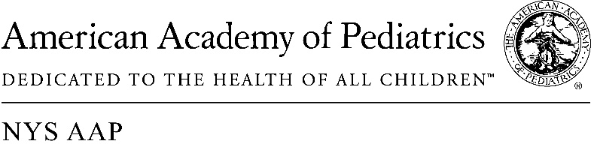 | The New York State  American Academy of Pediatrics  (NYS AAP) is a coalition of  AAP NY Chapters 1, 2 & 3

June 1, 20018
Memo of Support A.9550A/S.08774A

The New York State American Academy of Pediatrics, representing more than 5,000 pediatricians across the state strongly supports A. 9950/S. 08774
Eliminating the current barrier to nurses in attendance at a healthy birth to admit a healthy newborn to the regular nursery will streamline care of newborns and will in no way impact quality of care.
Nurses in the delivery room already check the newborn’s vital signs, and take the blood sample for newborn testing requirements. They also perform all other regimens for healthy newborns in the delivery room. They have full knowledge of the condition of the newborn. If there is any concern with the “health” of the newborn, this legislation clearly states that a pediatrician should be called in any instance where there is concern.
But birth is not a medical condition and most newborns are healthy and can be admitted to the regular nursery. The pediatrician would ordinarily do rounds in the morning. All babies would be seen by a pediatrician prior to discharge.
Most other states allow nurses to admit healthy newborns to the regular nursery. JCAHO, the Joint Commission on Hospital Accreditation does not require anything other than a nurse admitting a healthy newborn to the regular nursery. It is only an historic peculiarity of New York State regulation that maintains this unnecessary and burdensome requirement. It is time to New York State to join the rest of medicine and remove this barrier to good and efficient care of newborns.
We urge you to pass this legislation this year.

Contact:

Elie Ward, MSW
Director of Policy & Advocacy
New York State American Academy of Pediatrics
eward@aap.net

